**Lab Exercise-1**

**Course Name: Full Stack Web Development Course Code: PMCA601L**

**Semester: Winter 2024 – 25**

**Due Date: 13 – Jan – 2025**

1.Create a page aboutme.html that describes you. Include information such as:

a. Your name in the top of the page in large text and your address in smaller text

b. A description of you in <= 2 sentences. Emphasize important word(s) in **bold**.

c. Print a paragraph with 4 - 5 sentences. Each sentence should be a different font.

d. Print a paragraph that is a description of a book; include the title of the book as well as its author. Names and titles should be underlined, adjectives should be italicized and bolded.

e. A list of classes you are taking right now with a simple description of each with interesting subjects in marvellous colours. (**list**)

f. List your family members, friends and your favourite social leaders name as list under each category.

g. Two images that represent you when you're happy and sad.

h. Set the background color of the page as yellow.

i. Something about one of your neighbours (people sitting next to you, make it interesting as well.

j. Describe your skill level in programming languages.

**2.** Write a HTML code to design the following layout in formatted form and apply CSS box Model

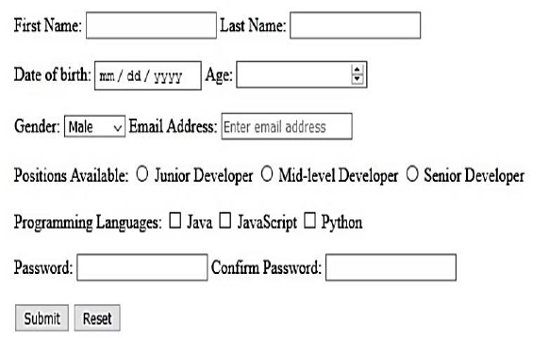

3. Design a HTML page which displays your course registration page details of Winter 2024-25 as it is

available in VTOP.

4.Write the HTML and CSS code to the following layout in flex design with following specifications.

|  |
| --- |
| a) All heading text color must be in white with font size as 15 px.  b) Choose different background color for each component in the layout. |

